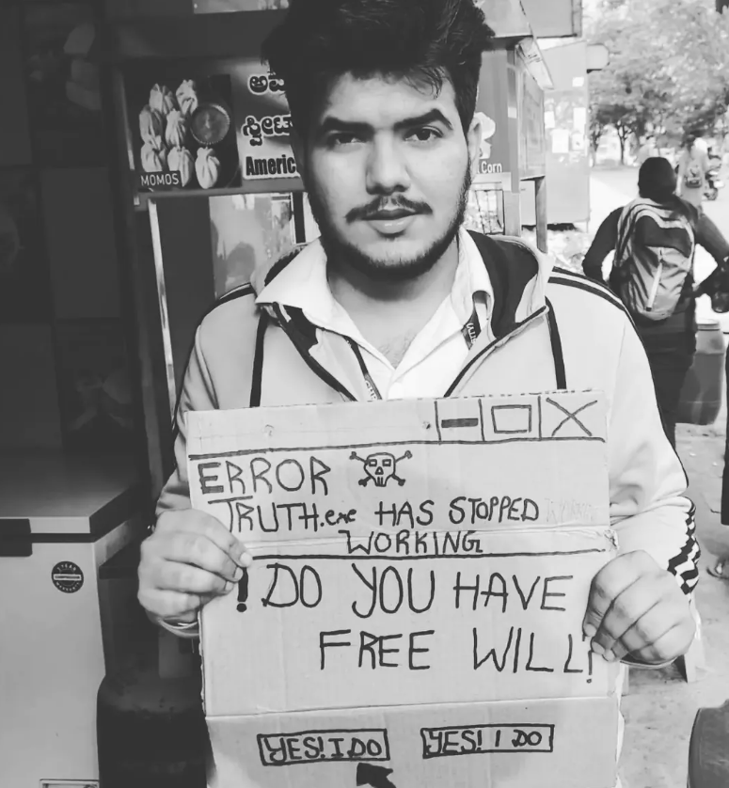

I never lie, I don't,

I tell that I love BTS, Friends, and beiber,
cause that makes a few people smile,
I tell sunflowers are overrated,
that Van gogh would be celebrated the same, without suicide,

When I call my parents at night,
I tell them I'm fine,
to all my hustler brothers,
I tell them, I am killing the grind,
I tell losing friends doesn't bother me,
that I'm above the little fights,
To my girlfriend who lives far,
I tell that my heart is alright,
I tell, that I, love my life,

I tell the people around,
that you are protected,
and you can freely exercise your rights,
that the police will, protect, you,
and you're not a criminal,
to be walking with friends at night,

I tell that the government does everything for the betterment of the nation,
and nothing is related with appeasement for when the election arrives,
that no movie is about propaganda,
and that every, fact ,on, the television,
is right,

I tell that the minorities do cause trouble,
and islotaed cases of lynching,
is sure justified,
that acts of violence can be ignored,
the anger has to be put somewhere,
as long as it's not genocide,

I tell I do not get hated for not knowing a language,
that everyone knows how be human,
that we are alike, deep inside,

I tell mental illnesses are just passing emotions,
that depression isn't you losing your mind,
that I'm just a baby who keeps crying, each night,

I tell pollution does not exist,
that we can cut trees left and right,
I tell,
don't worry, be happy,
doesn't matter how dark are the skies,

modern problems require modern solutions,
And guess one of them is lying,
to not be defiant, deviant, different, and to keep up with these pretentious times,

And so I was lying when I said I don't lie,
I lie, I do,
I lie to myself when I say,
I'll be alright if I speak the truth.

